Lab 2 - Paragraphs / Heading / Comments / Links

Instructions
- Answer the below question in the boxes if needed.
- For coding exercises, code on your computer and zip all your code before submission.
- Please submit the assignment after you finish.

Part 1: Headings, Paragraphs, and Links
Steps:

- Go to VS Code and open the folder that we created in Lab 1
- Open the HTML file (index.html) inside the folder.
- Add HTML code inside the body tags and try to create a page that looks like the screenshot below. (Hint: You will need to use header tag, p tag, a tag and hr tag to complete this)

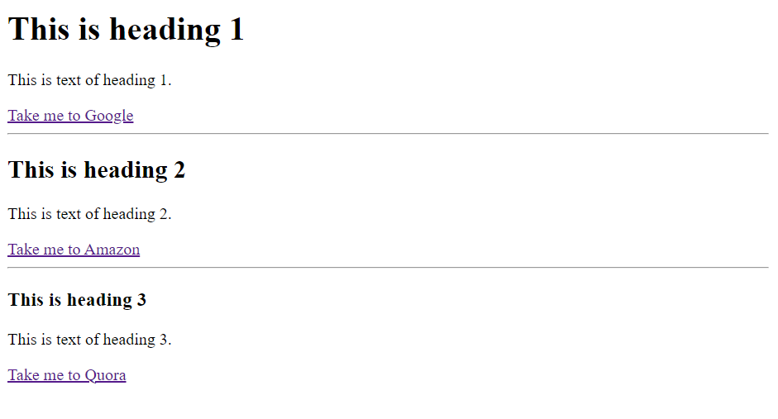
- Make sure to ONLY use HTML.
- The href for the 3 links in order are as follows:

  - https://www.google.com/
  - https://www.amazon.com/
  - https://www.quora.com/

Part 2: Add some comments about your code so we can understand it better

- Comments are a great way for us to understand the code you have written.
- Add some comments in the source code to explain your code or separate your code into different parts using comments.
- Zip the file and submit.

